Latihan PAW 2
Cara push paling bawah

Step by step
Buka terminal VS Code (Ctrl + ``) di folder Mencoba_Latihan_Paw2, lalu jalankan: ```powershell npm init -y npm install express@5 mongoose dotenv cors npm install --save-dev nodemon ``` Kirim output setelah selesai. Lalu kita siapkan konfigurasi Bagian A—tanpa memasukkan .env` ke Git.

PS C:\Users\User\Documents\PAW2\Mencoba_Latihan_Paw2> npm init -y
>> npm install express@5 mongoose dotenv cors
>> npm install --save-dev nodemon
Wrote to C:\Users\User\Documents\PAW2\Mencoba_Latihan_Paw2\package.json:

{
"name": "mencoba_latihan_paw2",
"version": "1.0.0",
"description": "",
"main": "index.js",
"scripts": {
"test": "echo \"Error: no test specified\" && exit 1"
},
"keywords": [],
"author": "",
"license": "ISC",
"type": "commonjs"
}

added 86 packages, and audited 87 packages in 7s

33 packages are looking for funding
run `npm fund` for details

found 0 vulnerabilities

added 26 packages, and audited 113 packages in 2s

38 packages are looking for funding
run `npm fund` for details

2 moderate severity vulnerabilities

To address all issues (including breaking changes), run:
npm audit fix --force

Run `npm audit` for details.
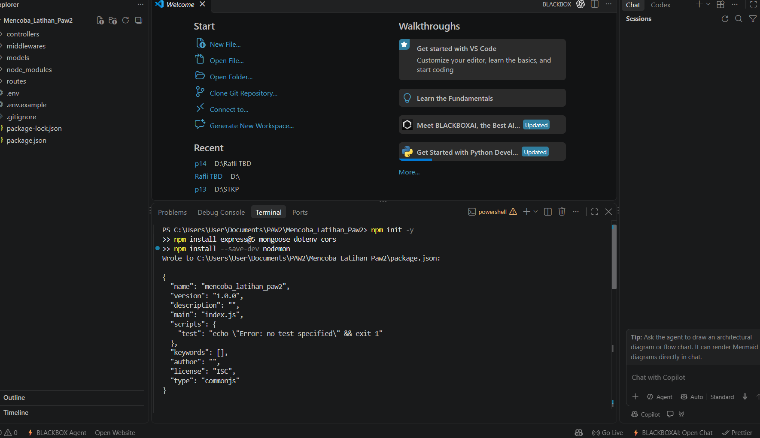
--------------------------------------------------
Dependensi terpasang. Dua moderate vulnerabilities tercatat—jangan jalankan npm audit fix --force dulu. Bagian A1: di PowerShell folder project, jalankan:
New-Item -ItemType Directory -Force routes,controllers,models,middlewares | Out-Null
@"
PORT=3000
MONGODB_URI=mongodb://127.0.0.1:27017/latihan_paw2_bunga
CORS_ORIGIN=http://localhost:5173
"@ | Set-Content .env
@"
PORT=3000
MONGODB_URI=mongodb://example.invalid/replace_me
CORS_ORIGIN=http://localhost:5173
"@ | Set-Content .env.example
@"
node_modules/
.env
"@ | Set-Content .gitignore
MONGODB_URI di .env.example cuma nilai palsu; .env lokal dipakai untuk koneksi. Kirim hasil Get-ChildItem -Force—pastikan .env dan .env.example muncul, tapi .env masuk .gitignore.

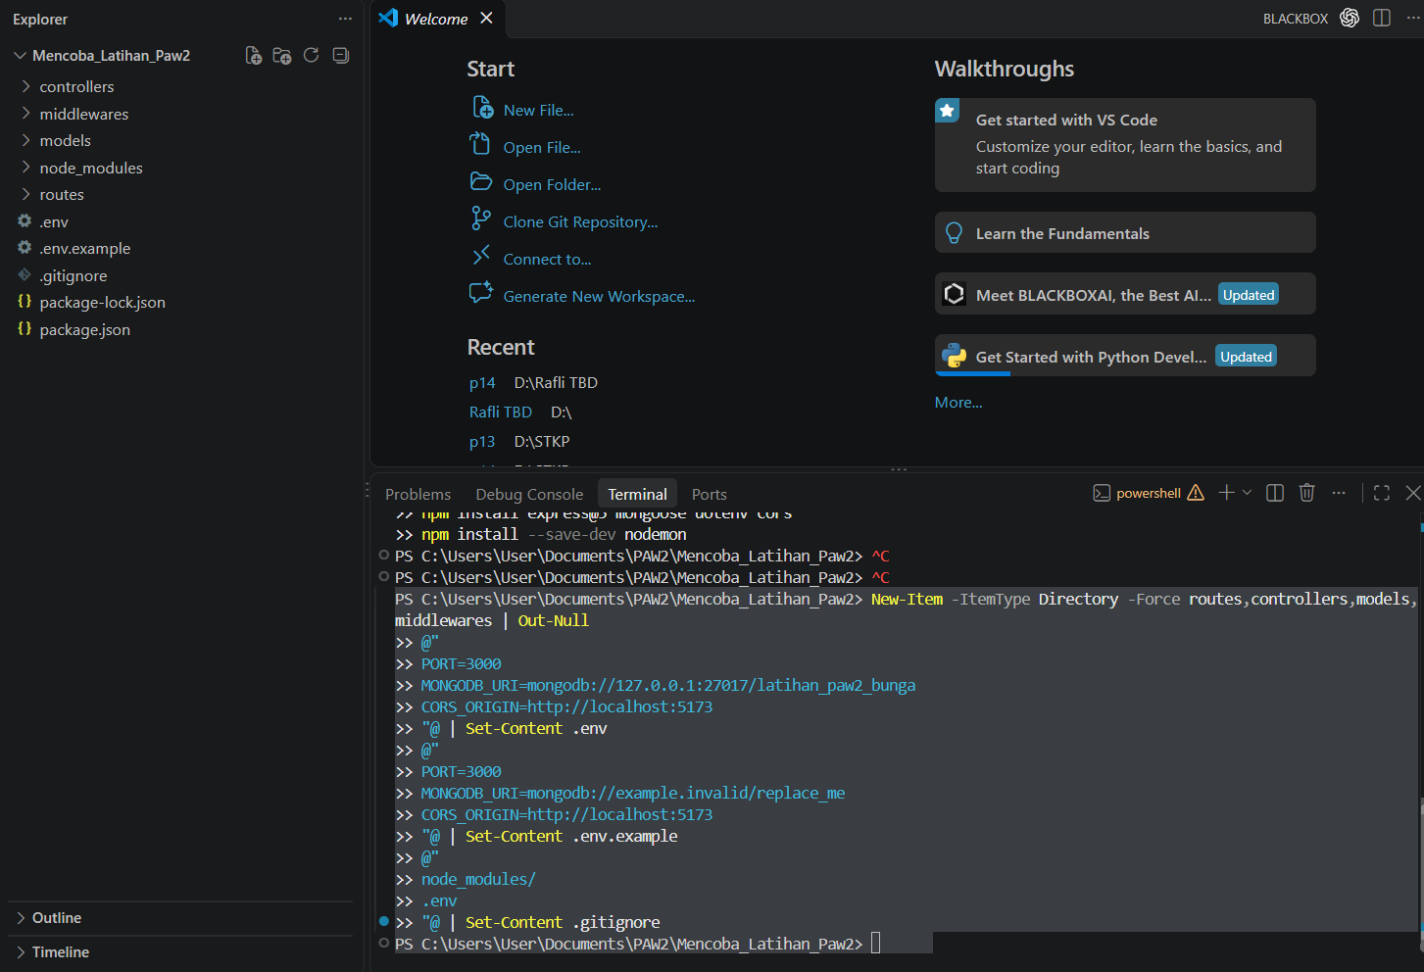
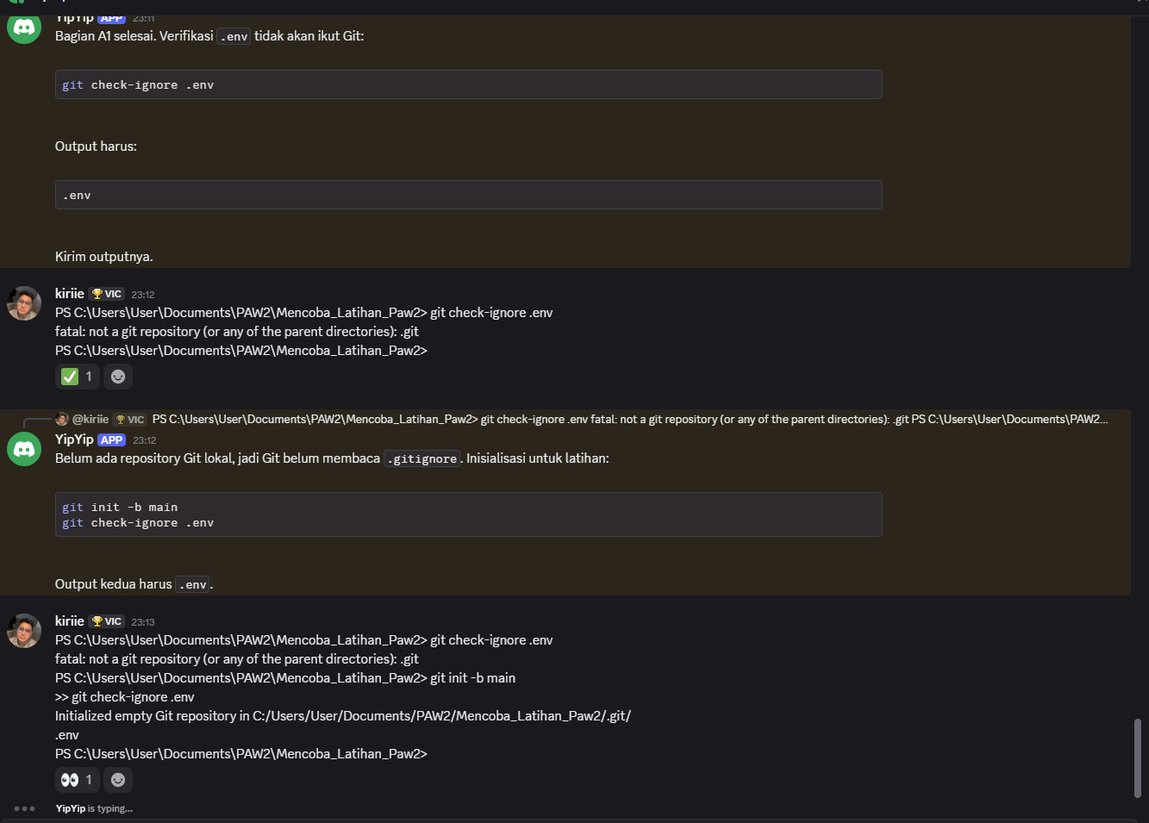
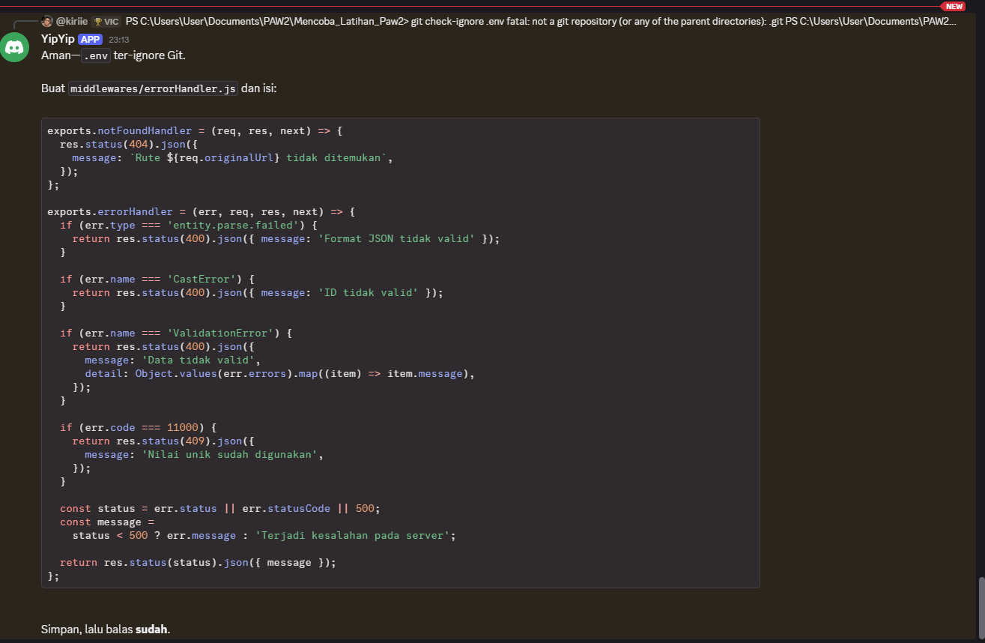
Aman—.env ter-ignore Git. Buat middlewares/errorHandler.js dan isi:
exports.notFoundHandler = (req, res, next) => {
res.status(404).json({
message: `Rute ${req.originalUrl} tidak ditemukan`,
});
};

exports.errorHandler = (err, req, res, next) => {
if (err.type === 'entity.parse.failed') {
return res.status(400).json({ message: 'Format JSON tidak valid' });
}

if (err.name === 'CastError') {
return res.status(400).json({ message: 'ID tidak valid' });
}

if (err.name === 'ValidationError') {
return res.status(400).json({
message: 'Data tidak valid',
detail: Object.values(err.errors).map((item) => item.message),
});
}

if (err.code === 11000) {
return res.status(409).json({
message: 'Nilai unik sudah digunakan',
});
}

const status = err.status || err.statusCode || 500;
const message =
status < 500 ? err.message : 'Terjadi kesalahan pada server';

return res.status(status).json({ message });
};
Simpan, lalu balas sudah.

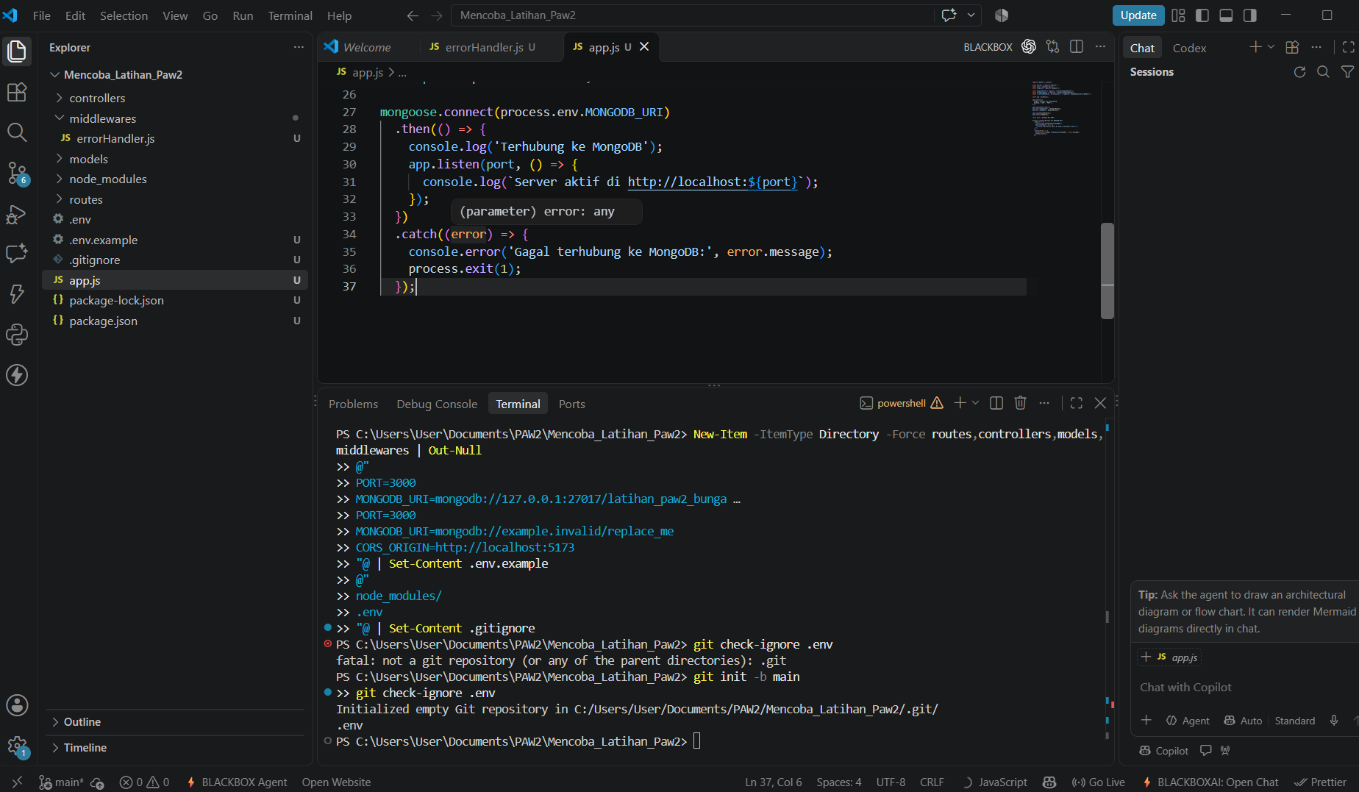
Buat app.js di root project. Ini menyelesaikan dotenv, CORS terbatas GET/POST, koneksi MongoDB sebelum server listen, dan error handler terakhir:
require('dotenv').config();

const express = require('express');
const cors = require('cors');
const mongoose = require('mongoose');

const bouquetRoutes = require('./routes/bouquetRoutes');
const categoryRoutes = require('./routes/categoryRoutes');
const { notFoundHandler, errorHandler } = require('./middlewares/errorHandler');

const app = express();

app.use(cors({
origin: process.env.CORS_ORIGIN,
methods: ['GET', 'POST'],
}));

app.use(express.json());
app.use('/categories', categoryRoutes);
app.use('/bouquets', bouquetRoutes);

app.use(notFoundHandler);
app.use(errorHandler);

const port = process.env.PORT;

mongoose.connect(process.env.MONGODB_URI)
.then(() => {
console.log('Terhubung ke MongoDB');
app.listen(port, () => {
console.log(`Server aktif di http://localhost:${port}`);
});
})
.catch((error) => {
console.error('Gagal terhubung ke MongoDB:', error.message);
process.exit(1);
});
Jangan jalankan dulu—route files belum dibuat. Simpan, lalu balas sudah.

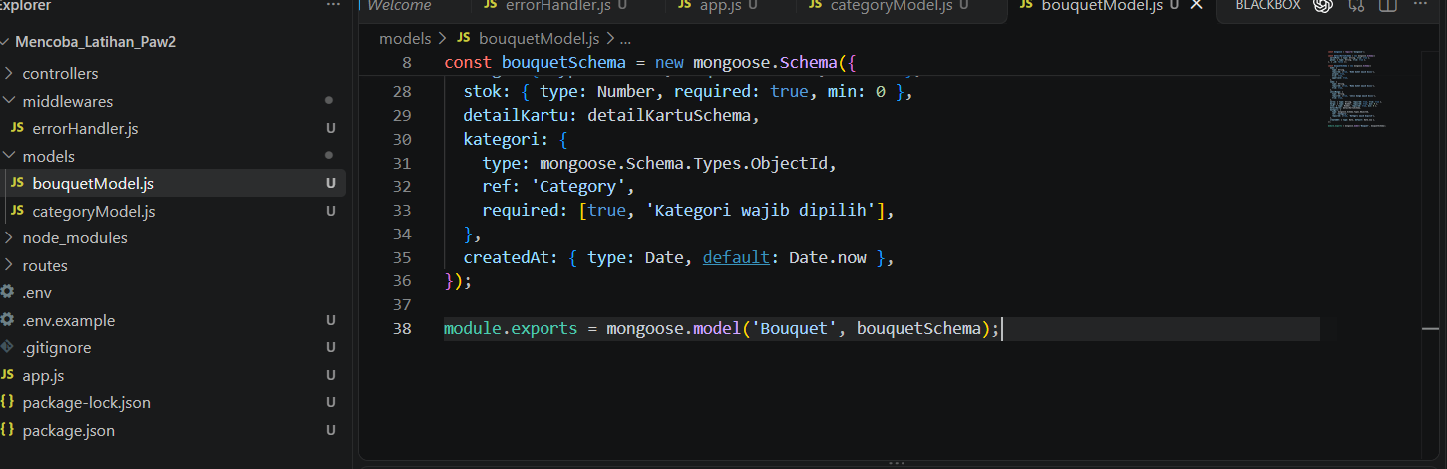
Lanjut Bagian B: model data. Buat models/categoryModel.js:
const mongoose = require('mongoose');

const categorySchema = new mongoose.Schema({
kode: {
type: String,
required: [true, 'Kode kategori wajib diisi'],
unique: true,
trim: true,
uppercase: true,
},
nama: {
type: String,
required: [true, 'Nama kategori wajib diisi'],
trim: true,
},
});

module.exports = mongoose.model('Category', categorySchema);
Lalu buat models/bouquetModel.js. detailKartu contoh embedding; kategori adalah referencing ke Category:
const mongoose = require('mongoose');

const detailKartuSchema = new mongoose.Schema({
warnaPita: { type: String, trim: true },
pesan: { type: String, trim: true },
}, { _id: false });

const bouquetSchema = new mongoose.Schema({
kode: {
type: String,
required: [true, 'Kode buket wajib diisi'],
unique: true,
trim: true,
uppercase: true,
},
nama: {
type: String,
required: [true, 'Nama buket wajib diisi'],
trim: true,
},
jenisBunga: {
type: String,
required: [true, 'Jenis bunga wajib diisi'],
trim: true,
},
warna: { type: String, required: true, trim: true },
harga: { type: Number, required: true, min: 0 },
stok: { type: Number, required: true, min: 0 },
detailKartu: detailKartuSchema,
kategori: {
type: mongoose.Schema.Types.ObjectId,
ref: 'Category',
required: [true, 'Kategori wajib dipilih'],
},
createdAt: { type: Date, default: Date.now },
});

module.exports = mongoose.model('Bouquet', bouquetSchema);
Simpan dua model, lalu bilang sudah.

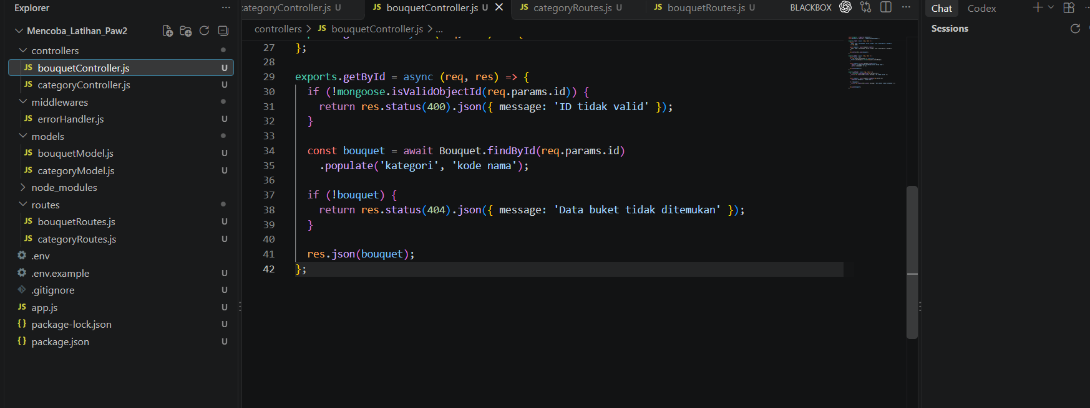

YipYipAPP — 23:17
Bagus. Buat controllers/categoryController.js:
const Category = require('../models/categoryModel');

exports.create = async (req, res) => {
const { kode, nama } = req.body;
const category = await Category.create({ kode, nama });
res.status(201).json(category);
};

exports.getAll = async (req, res) => {
const categories = await Category.find().sort({ kode: 1 });
res.json(categories);
};
Buat controllers/bouquetController.js. POST hanya mengambil field yang diizinkan; GET daftar menyediakan filter persis dan projection:
const mongoose = require('mongoose');
const Bouquet = require('../models/bouquetModel');

exports.create = async (req, res) => {
const {
kode, nama, jenisBunga, warna, harga, stok, detailKartu, kategori,
} = req.body;

const bouquet = await Bouquet.create({
kode, nama, jenisBunga, warna, harga, stok, detailKartu, kategori,
});

res.status(201).json(bouquet);
};

exports.getAll = async (req, res) => {
const filter = {};
if (req.query.jenisBunga !== undefined) {
filter.jenisBunga = String(req.query.jenisBunga);
}

const bouquets = await Bouquet.find(filter)
.select('_id kode nama jenisBunga warna harga stok')
.sort({ createdAt: -1 });

res.json(bouquets);
};

exports.getById = async (req, res) => {
if (!mongoose.isValidObjectId(req.params.id)) {
return res.status(400).json({ message: 'ID tidak valid' });
}

const bouquet = await Bouquet.findById(req.params.id)
.populate('kategori', 'kode nama');

if (!bouquet) {
return res.status(404).json({ message: 'Data buket tidak ditemukan' });
}

res.json(bouquet);
};
Simpan kedua file. Lalu bilang sudah; kita buat routes. 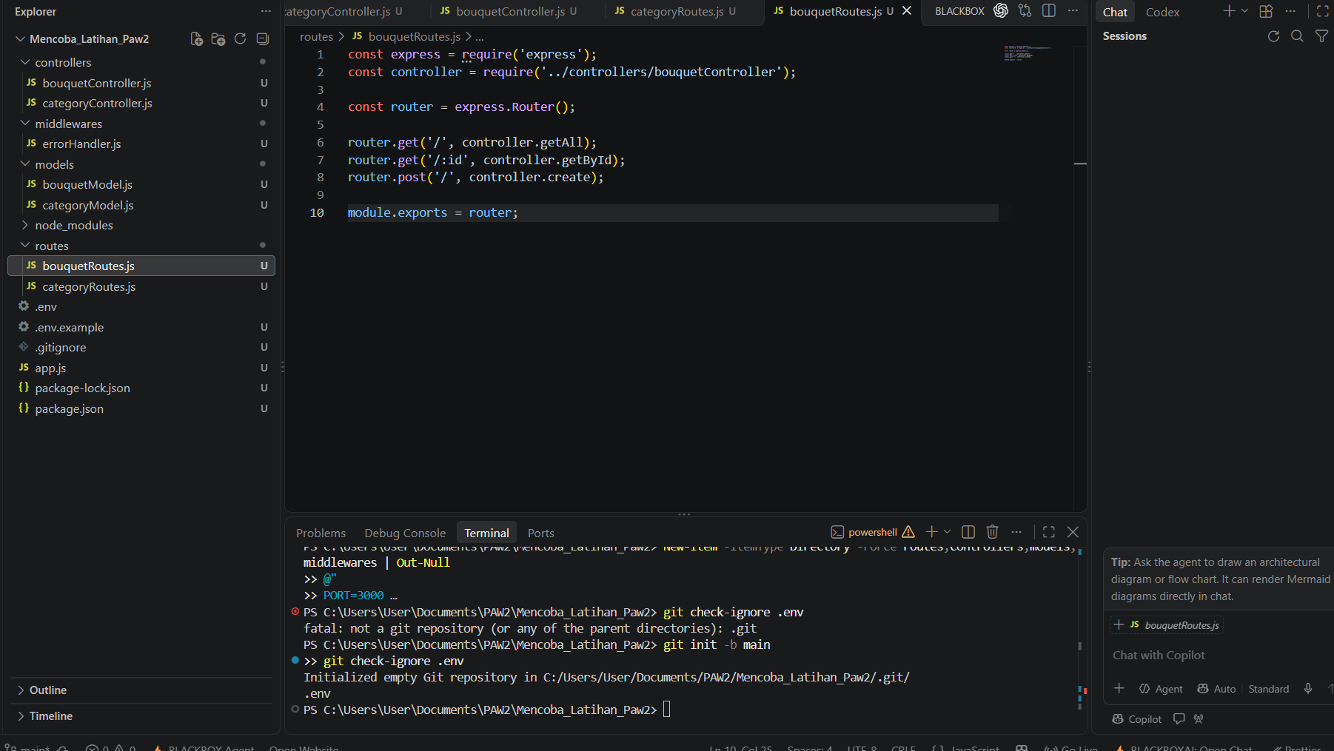

Buat routes/categoryRoutes.js:
const express = require('express');
const controller = require('../controllers/categoryController');

const router = express.Router();

router.get('/', controller.getAll);
router.post('/', controller.create);

module.exports = router;
Buat routes/bouquetRoutes.js:
const express = require('express');
const controller = require('../controllers/bouquetController');

const router = express.Router();

router.get('/', controller.getAll);
router.get('/:id', controller.getById);
router.post('/', controller.create);

module.exports = router;
Simpan keduanya. Lalu balas sudah.

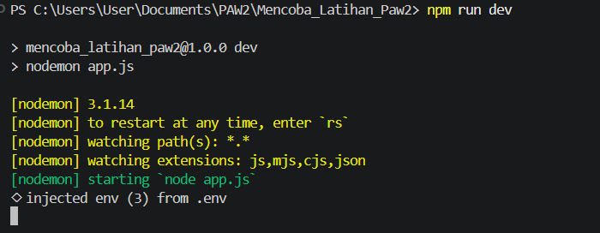
Semua file utama sudah lengkap, dan seluruh file JavaScript lolos node --check. .env juga ter-ignore Git. Berikutnya jalankan MongoDB Server, lalu di terminal project:
npm run dev
Kalau muncul Terhubung ke MongoDB dan Server aktif di http://localhost:3000, kirim output-nya.

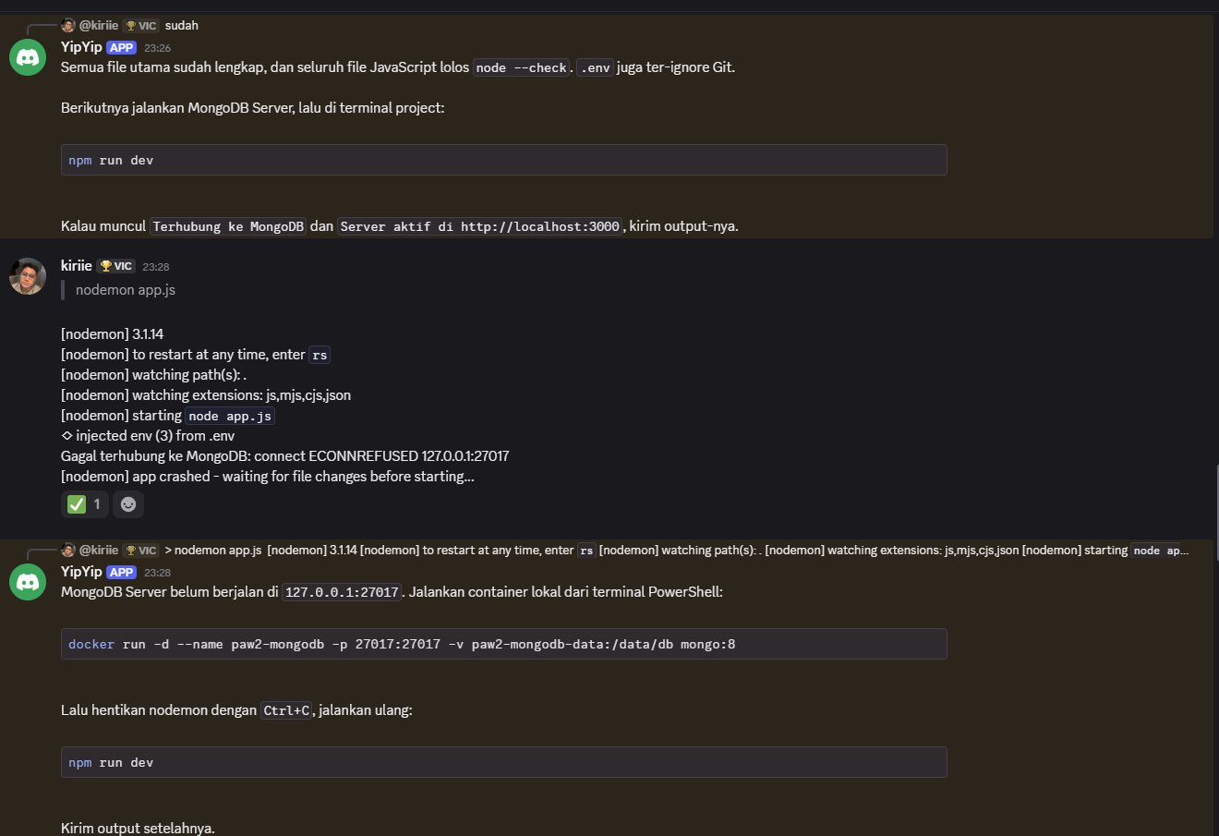
Docker Desktop belum berjalan—makanya MongoDB tidak bisa start. Error ECONNREFUSED karena port 27017 belum punya server.
- Tekan Ctrl+C untuk hentikan npm run dev.
- Buka Docker Desktop dan tunggu status Engine running.
- Jalankan:
docker run -d --name paw2-mongodb -p 27017:27017 -v paw2-mongodb-data:/data/db mongo:8
Kalau container sudah ada, pakai:
docker start paw2-mongodb
- Setelah MongoDB hidup, jalankan npm run dev lagi.

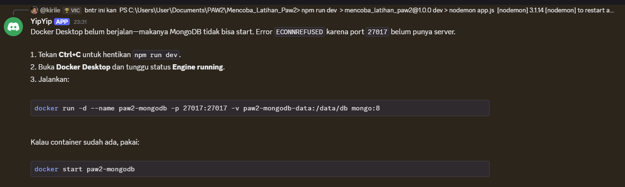
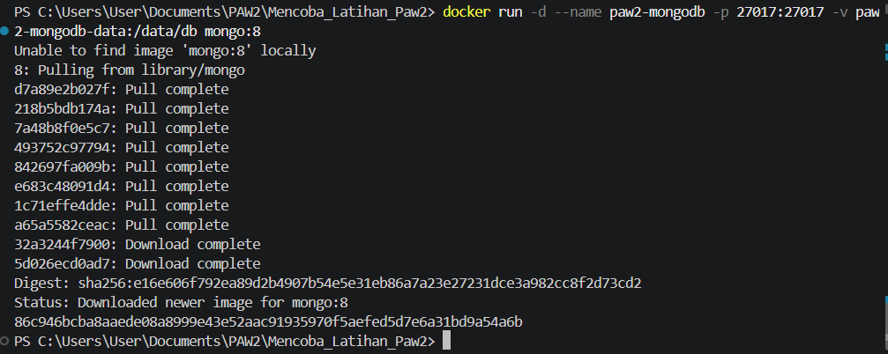
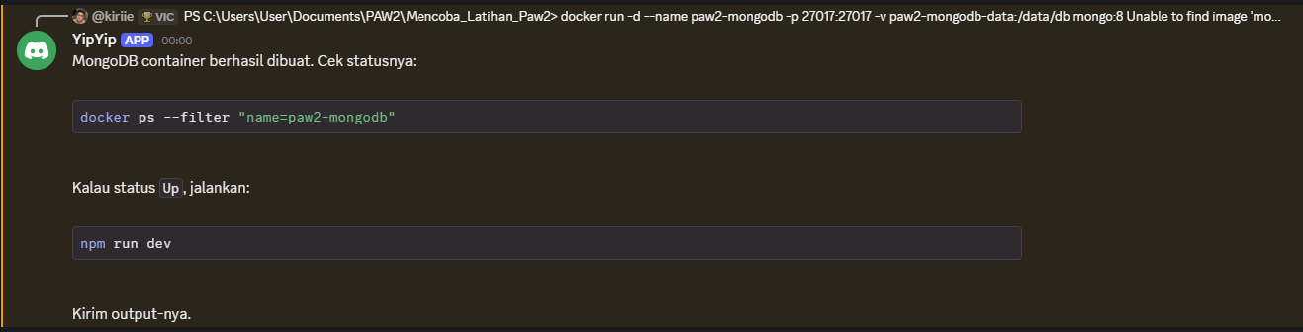
PS C:\Users\User\Documents\PAW2\Mencoba_Latihan_Paw2> docker ps --filter "name=paw2-mongodb"
CONTAINER ID IMAGE COMMAND CREATED STATUS PORTS NAMES
86c946bcba8a mongo:8 "docker-entrypoint.s…" About a minute ago Up About a minute 0.0.0.0:27017->27017/tcp, [::]:27017->27017/tcp paw2-mongodb
PS C:\Users\User\Documents\PAW2\Mencoba_Latihan_Paw2> npm run dev

> mencoba_latihan_paw2@1.0.0 dev
> nodemon app.js

[nodemon] 3.1.14
[nodemon] to restart at any time, enter `rs`
[nodemon] watching path(s): *.*
[nodemon] watching extensions: js,mjs,cjs,json
[nodemon] starting `node app.js`
◇ injected env (3) from .env
Terhubung ke MongoDB
Server aktif di http://localhost:3000

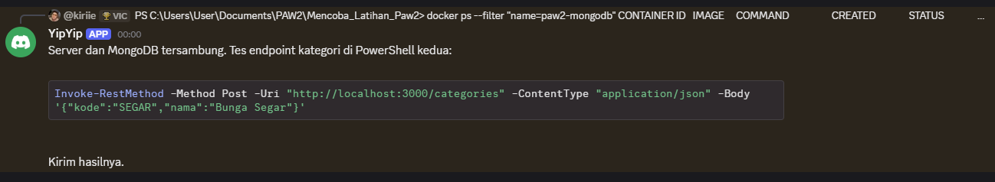
PS C:\Users\User\Documents\PAW2\Mencoba_Latihan_Paw2> Invoke-RestMethod -Method Post -Uri "http://localhost:3000/categories" -ContentType "application/json" -Body '{"kode":"SEGAR","nama":"Bunga Segar"}'

kode nama _id __v
---- ---- --- ---
SEGAR Bunga Segar 6aeb64d40b7c6a3160439290 0

PS C:\Users\User\Documents\PAW2\Mencoba_Latihan_Paw2>
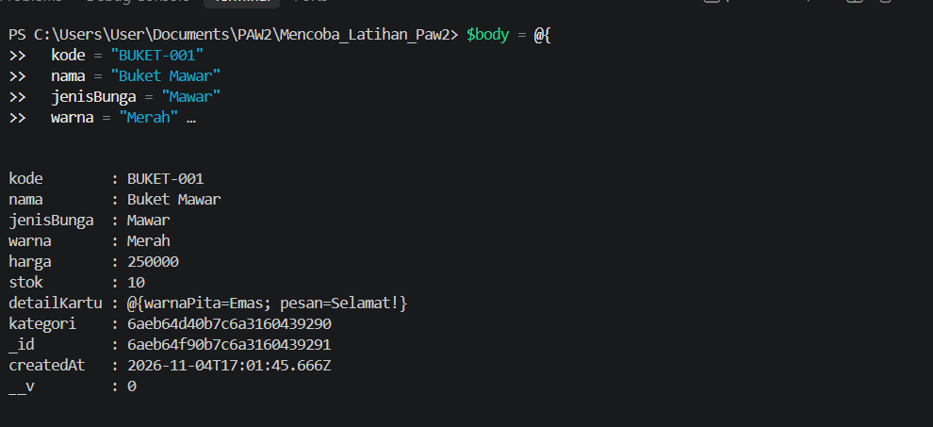

Kategori berhasil dibuat. Tes POST bouquet—ganti kategori dengan ID hasilmu jika berbeda:
$body = @{
kode = "BUKET-001"
nama = "Buket Mawar"
jenisBunga = "Mawar"
warna = "Merah"
harga = 250000
stok = 10
detailKartu = @{
warnaPita = "Emas"
pesan = "Selamat!"
}
kategori = "6aeb64d40b7c6a3160439290"
} | ConvertTo-Json -Depth 5

Invoke-RestMethod -Method Post `
-Uri "http://localhost:3000/bouquets" `
-ContentType "application/json" `
-Body $body
Kirim hasilnya.
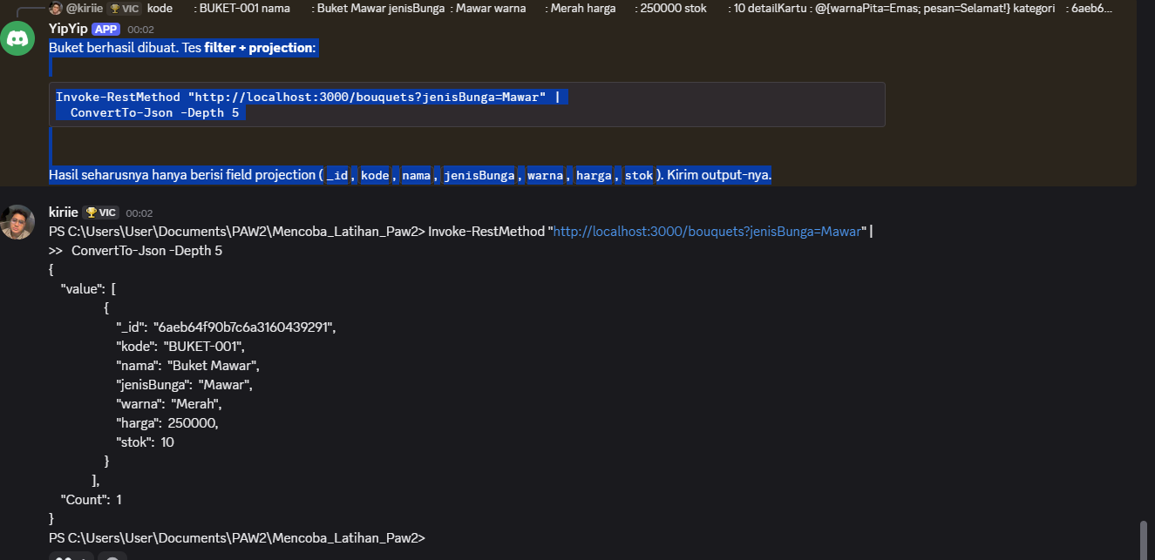

Buket berhasil dibuat. Tes filter + projection:
Invoke-RestMethod "http://localhost:3000/bouquets?jenisBunga=Mawar" |
ConvertTo-Json -Depth 5
Hasil seharusnya hanya berisi field projection (_id, kode, nama, jenisBunga, warna, harga, stok). Kirim output-nya.

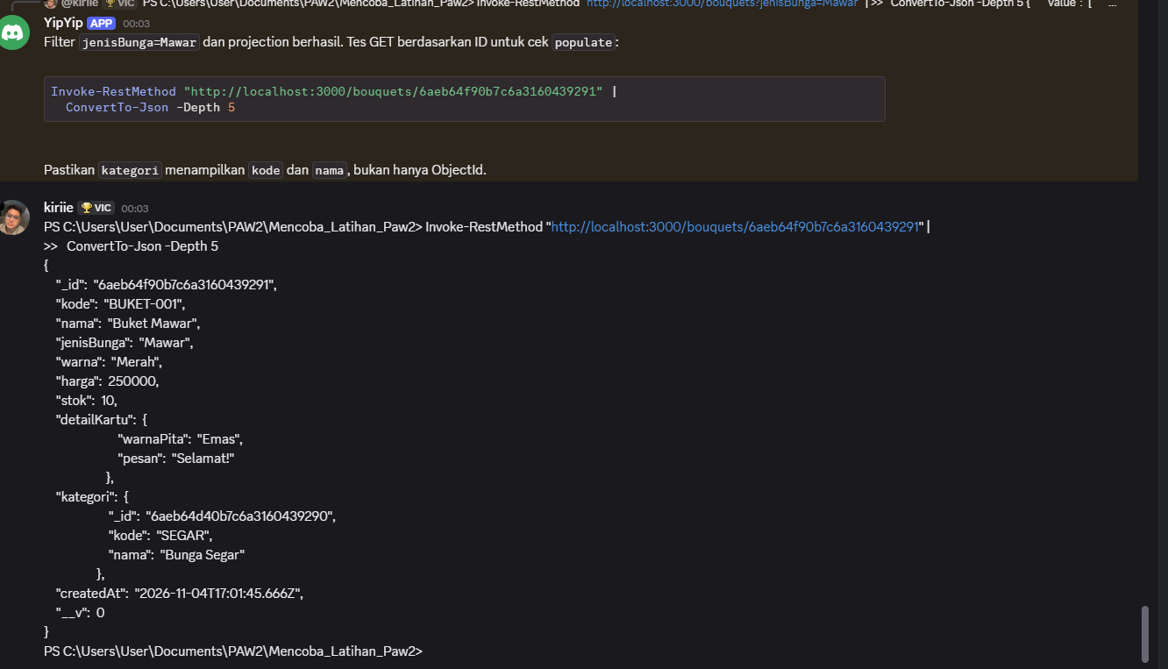
Filter jenisBunga=Mawar dan projection berhasil. Tes GET berdasarkan ID untuk cek populate:
Invoke-RestMethod "http://localhost:3000/bouquets/6aeb64f90b7c6a3160439291" |
ConvertTo-Json -Depth 5
Pastikan kategori menampilkan kode dan nama, bukan hanya ObjectId.
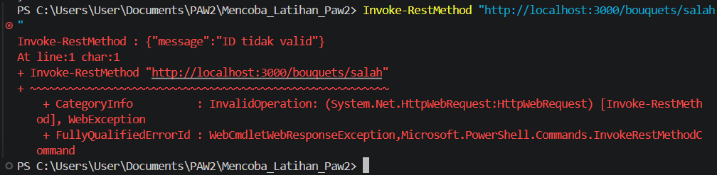

Berhasil—GET by ID mengembalikan semua field, detailKartu ter-embed, dan kategori ter-populate (SEGAR, Bunga Segar). Tes ID dengan format salah:
Invoke-RestMethod "http://localhost:3000/bouquets/salah"
Harus mendapat HTTP 400 dengan JSON {"message":"ID tidak valid"}.
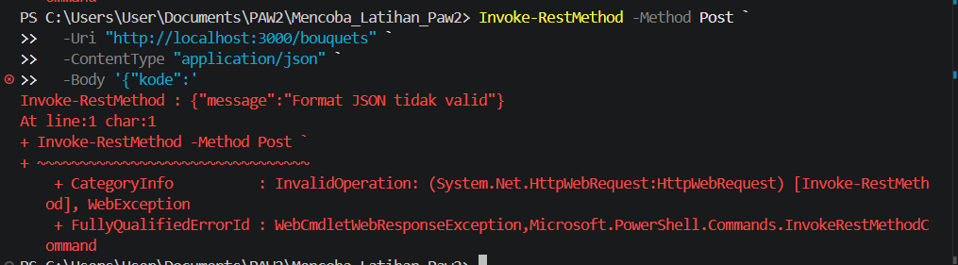
Bagus. Tes terakhir untuk error handling: kirim JSON rusak dan cek 400:
Invoke-RestMethod -Method Post `
-Uri "http://localhost:3000/bouquets" `
-ContentType "application/json" `
-Body '{"kode":'
Harus ada pesan Format JSON tidak valid. Pastikan respons status 400.

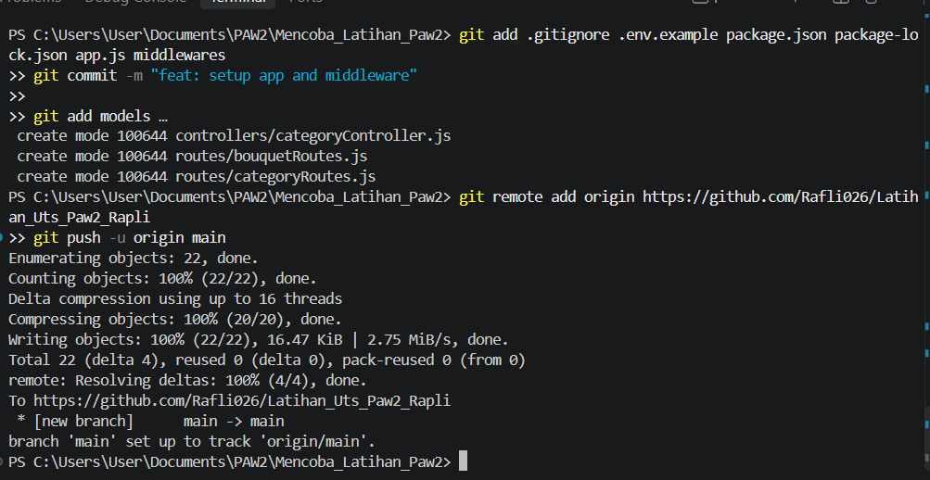
Okei skrg gini kalau mau mongo db compas
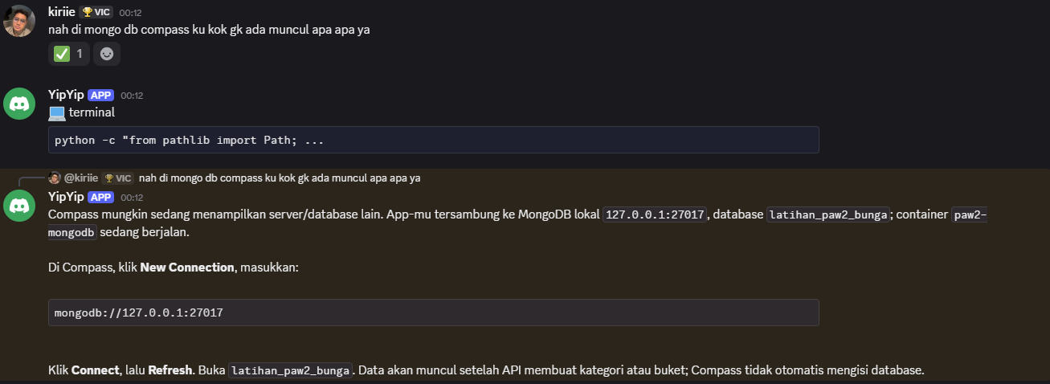
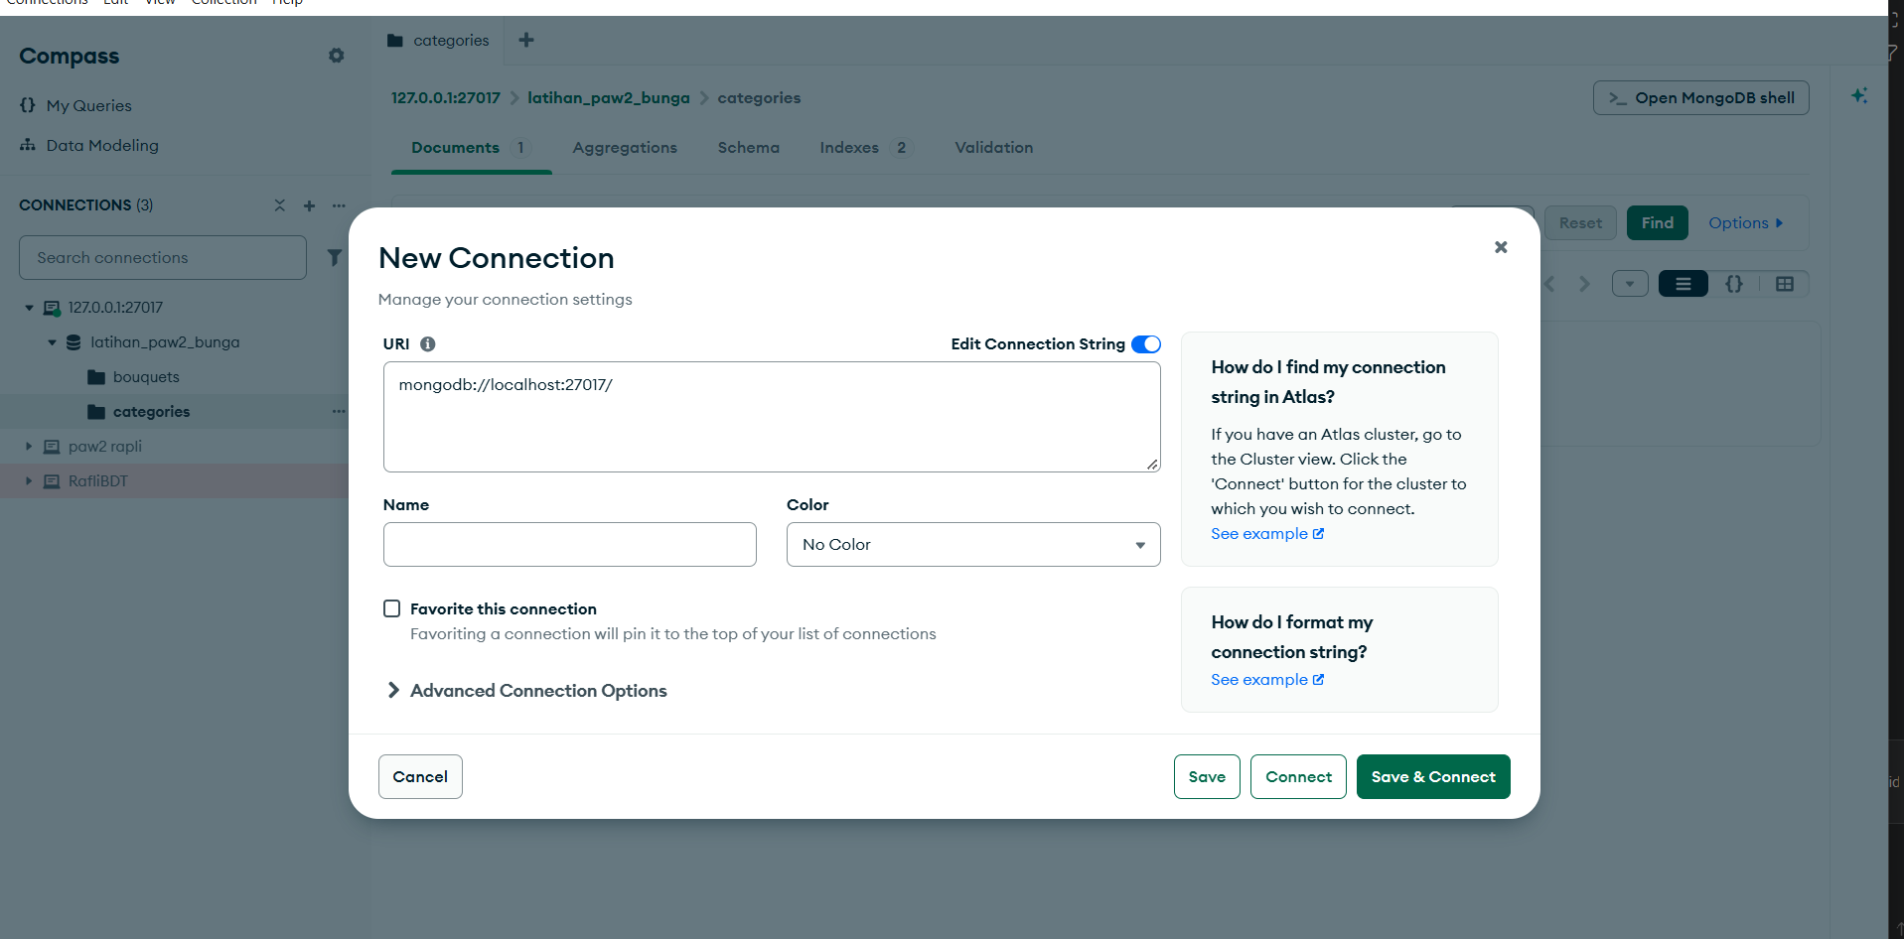
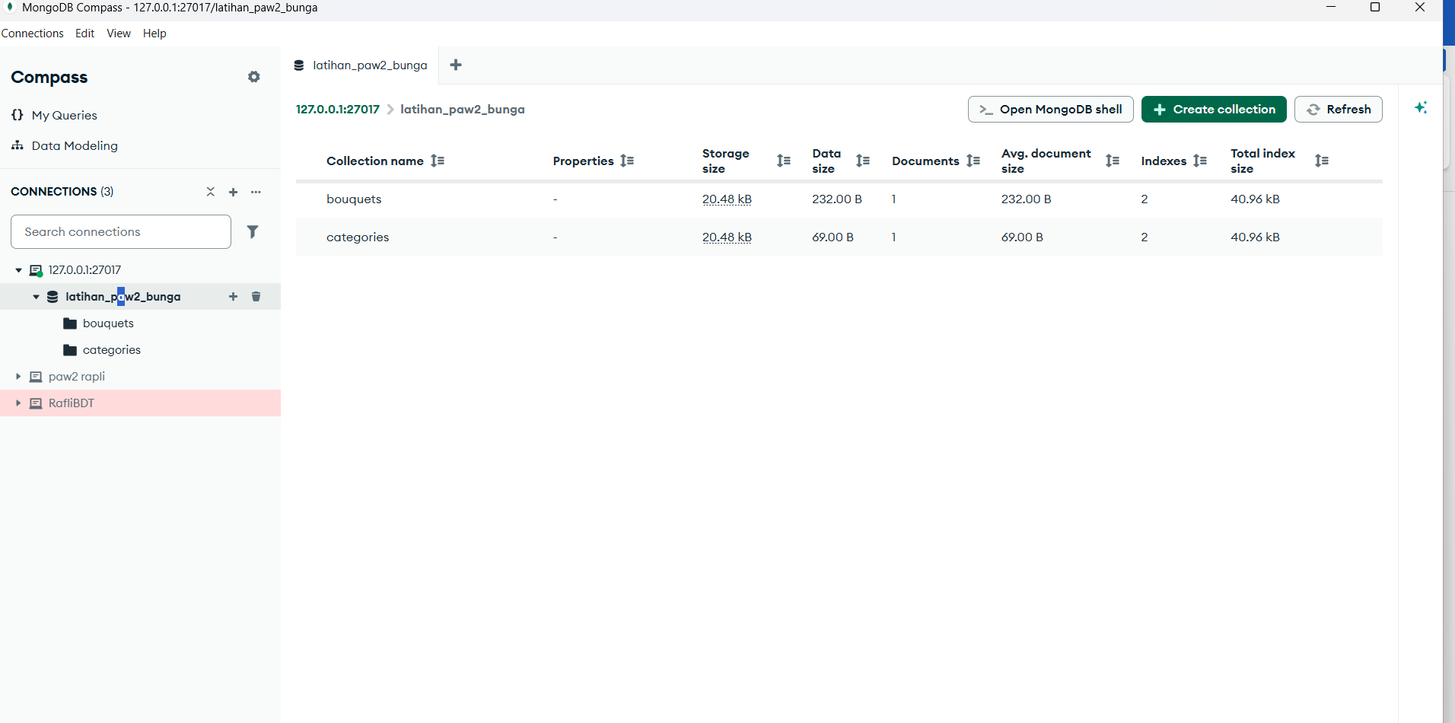
CARA MONGO DB ATLAS
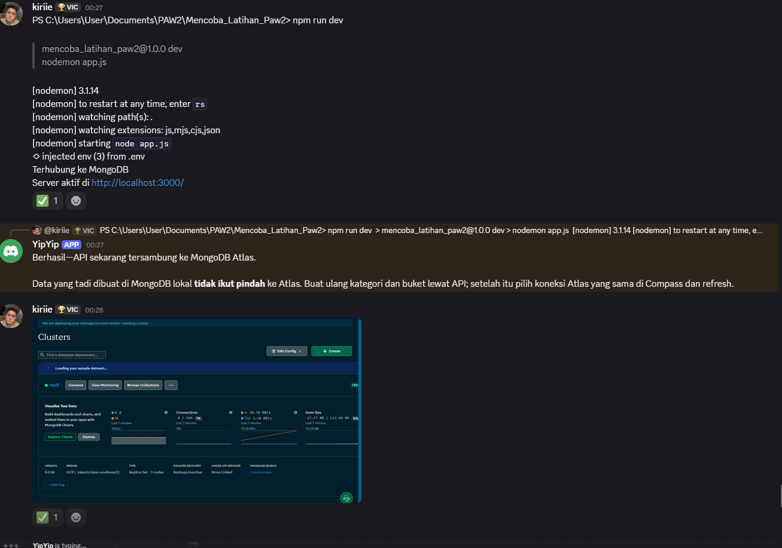
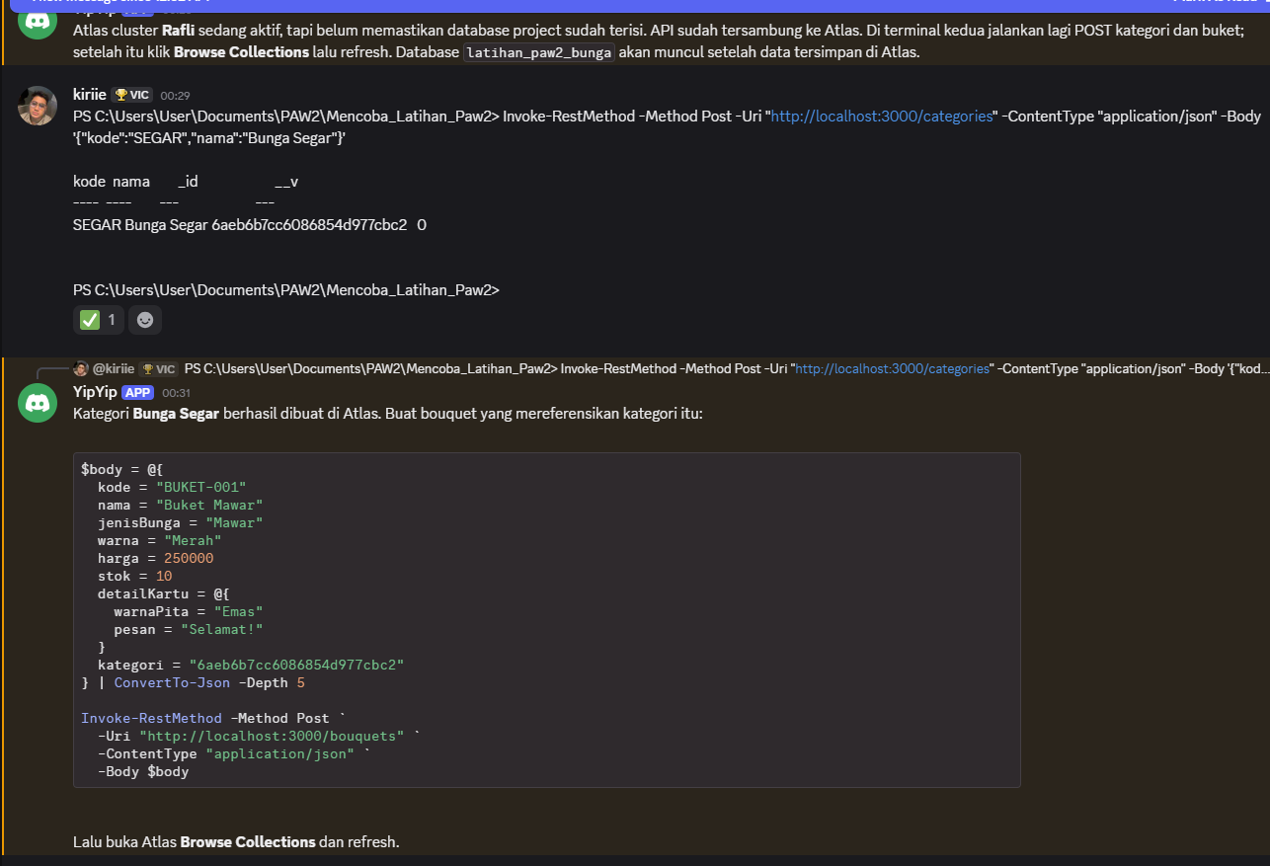
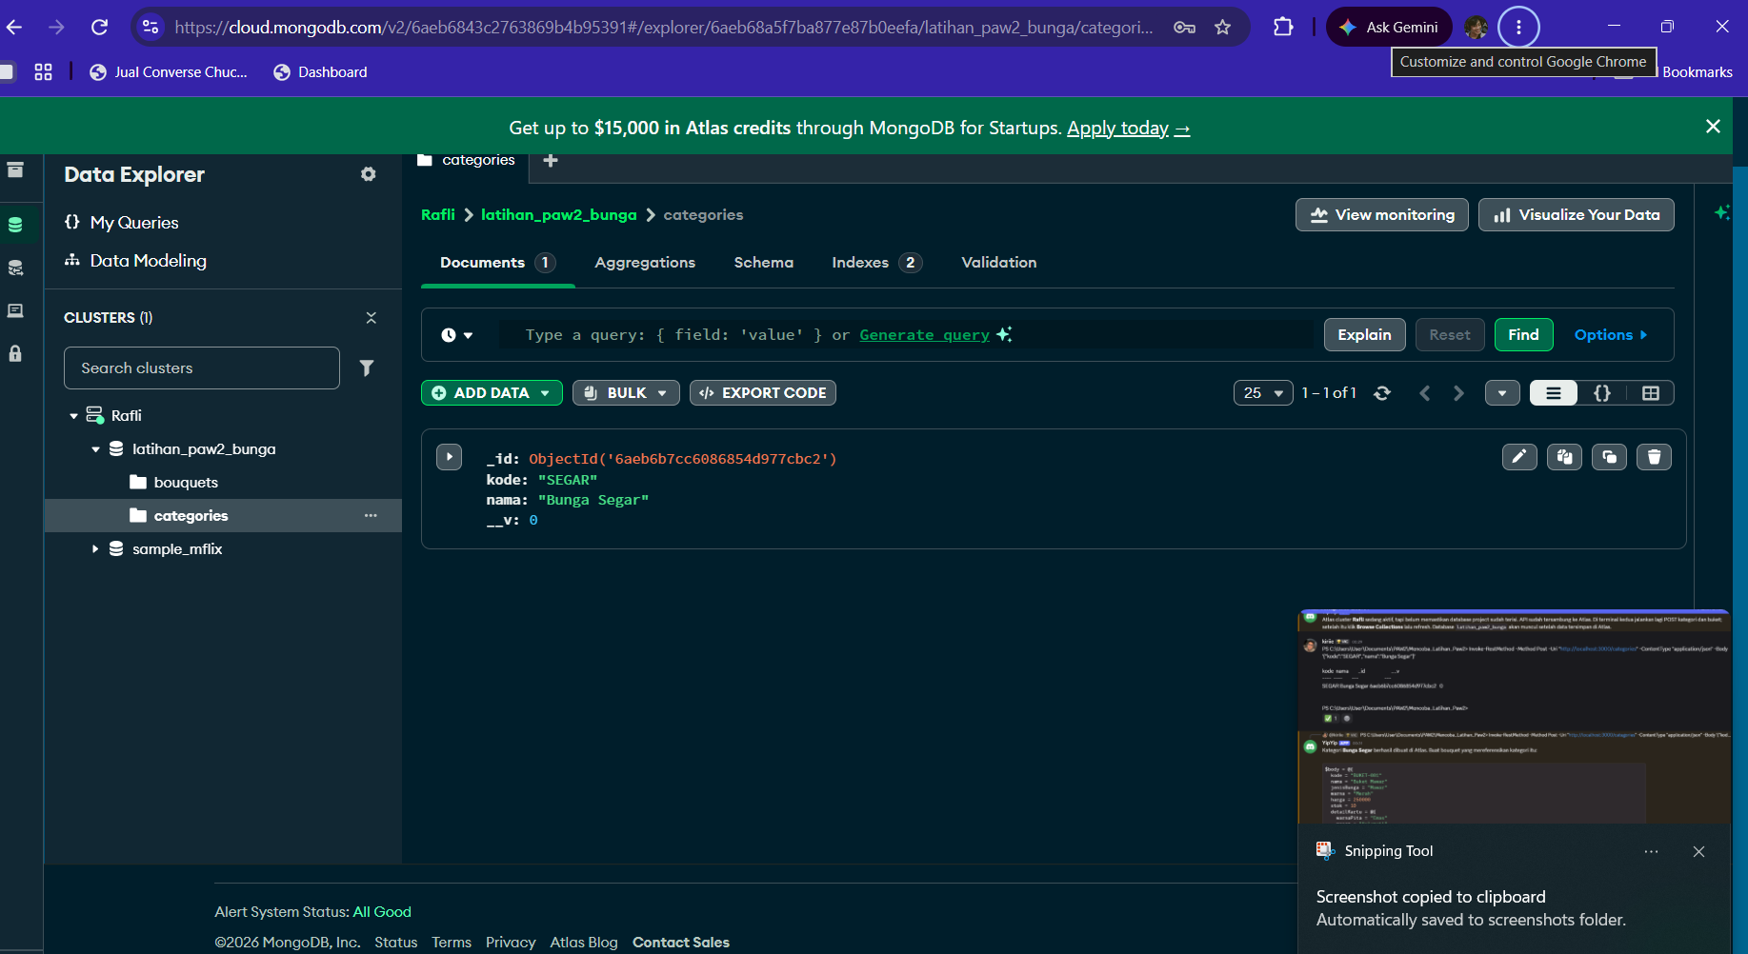
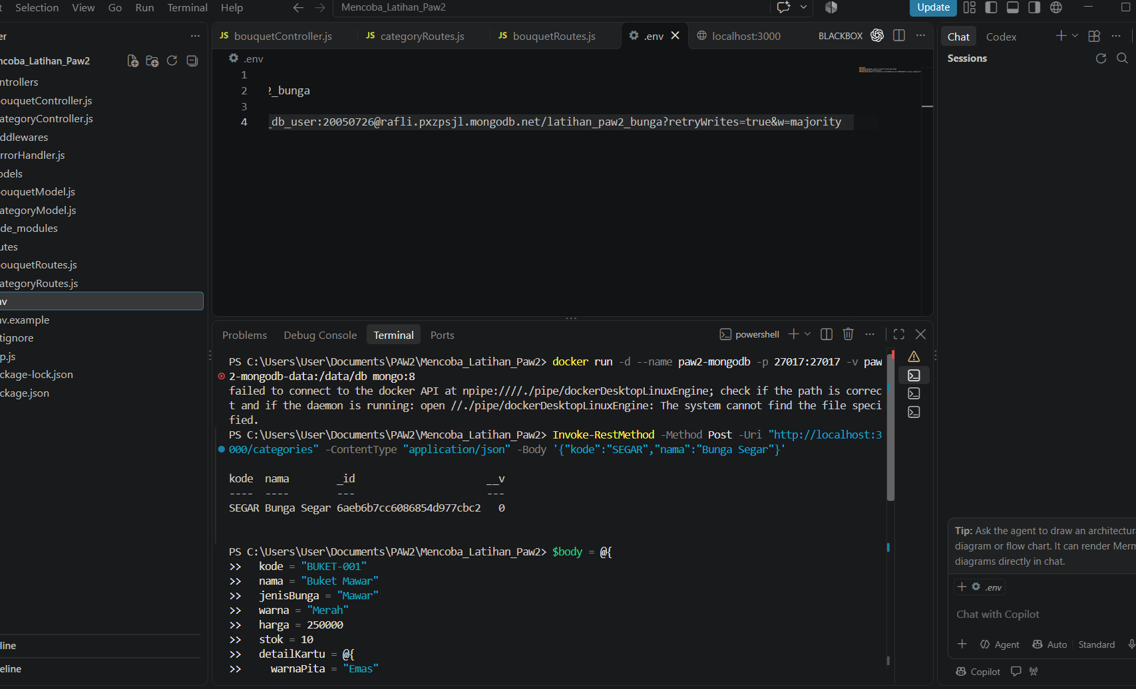

CARA PUSH
Folder latihan sudah punya Git branch main, tapi belum ada commit dan remote GitHub. Buat repo baru di GitHub—jangan pakai repo Tugas 3 lama. Contoh nama: latihan-uts-paw2-bunga, pilih Public, dan jangan centang README/license. Di PowerShell, dari folder project, set identitas commit lokal:
git config user.name "Sherafli Rusli"
git config user.email "Sherafliruslii26@Gmail.com"
Buat 3 commit seperti pola UTS:
git add .gitignore .env.example package.json package-lock.json app.js middlewares
git commit -m "feat: setup app and middleware"

git add models
git commit -m "feat: add MongoDB models"

git add controllers routes
git commit -m "feat: add bouquet API endpoints"
Sambungkan ke URL repo baru yang GitHub berikan, lalu push:
git remote add origin https://github.com/USERNAME/latihan-uts-paw2-bunga.git
git push -u origin main
Ganti USERNAME dengan username GitHub-mu. .env harus tetap tidak ikut—sudah ter-ignore.

